Test yourself 1 - trang 40 Sách Bài Tập (SBT) Tiếng anh 12 mới
Tổng hợp các bài tập trong phần Test yourself 1 - trang 40 Sách Bài Tập (SBT) Tiếng anh 12 mới
1. Listen to the following sentences and underline the sounds that are affected by assimilation. (Nghe những câu sau đây và gạch dưới những âm thanh mà bị ảnh hưởng bởi sự đồng hóa.)
- The best man is standing next to the proud groom.
- We have already visited the Grand Canyon and the Golden Gate Bridge.
- She put the wet blanket into a white bag.
- That old man placed the closed book on the desk and stood up.
- My mother went to the open market to buy some chicken breasts.
- The rose show is organised in Great Britain every summer.
- In this university, equal numbers of both sexes enrolled in the earth science course.
- They have turned many highland castles into first class hotels.
Đáp án:
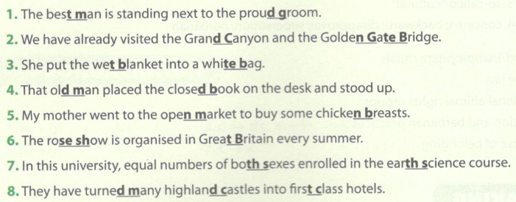
2 Use the correct form of the words in the box to complete the sentences. (Hãy sử dụng hình thức đúng của các từ trong hộp để hoàn thành câu.)
deplete employ conserve agriculture efficiency
- A lot of forests have been cut down to make way for______________ land.
- The world's fish populations are at risk of_____________.
- As the economy grew, the country's ____________ rate dropped below 5% in February.
- The candidate decided to stop the campaign because it was too expensive and ____________.
- The first ____________ areas were designated in 1967 in England.
Đáp án:
1. agricultural: Rất nhiều khu rừng đã bị đốn hạ để làm chỗ cho đất nông nghiệp
2. depletion: quần thể cá trên thế giới đang có nguy cơ cạn kiệt
3. unemployment: Khi nền kinh tế tăng trưởng, tỷ lệ thất nghiệp của nước này đã giảm xuống dưới 5% vào tháng Hai.
4. inefficient: ứng cử viên đã quyết định ngừng chiến dịch vì nó quá tốn kém và không hiệu quả
5. conservation: khu bảo tồn đầu tiên được thiết kế vào năm 1967 tại Anh.
3. Choose the best answer to complete each sentence by circling A, B, C or D. (Chọn câu trả lời đúng nhất để hoàn thành mỗi câu bằng cách khoanh tròn A, B, C hoặc D.)
1. It is recommended that people__________ regular exercise.
A. took B. to take C. take D. taking
2. In the past, families were bigger because people__________ more children.
A. were having B. had C. have D. have had
3. The police have advised people that their doors__________ locked at all times.
A. be kept B. kept C. to be kept D. being kept
4. When I_____________ reading The Quiet American, I wanted to read other novels by Graham Greene.
A. was finishing B. used to finish C. finish D. finished
5. __________ water is considered___________ vital source of life, but___________ water of Colox City is so polluted that people could die if they only drank____________ drop of it.
A. x/a/the/a B. The/the/the/a C. the/the/the/the D. x/x/x/x
6. More than ten students have failed the exams, which_______ the class teacher.
A. had surprised B. have surprising C. is surprising D. has surprised
7. How much do you charge _______ a bunch of red roses?
A. to B. in C. for D. with
8. Before the Treaty of Versailles in 1919, many Germans _______ that the German army______ .
A. had not believed/was defeated B. did not believe/had been defeated
C. were not believing have been defeated D. have not believed/had been defeated
9. He _______ about his noisy neighbours five times today.
A. has been complaining B. has complained
C. would complain D. used to complain
10. As the plane was climbing________________ into the sky, the ground was getting________ away.
A. higher/far and far B. higher/a little further
C. higher and higher/further and further D. highest and highest/furthest and furthest
11. I am exhausted. I _______ around the whole afternoon trying to clean the house before the guests arrive.
A. have been running B. have run C. be running D. was running
12. I _______ Mary since this morning. Do you have any idea where she is?
A. have been phoned B. am phoning
C. have phoned D. have been phoning
13. He is not______ and finds it difficult to pay for daily necessities.
A. well-paid B. well-paying C. well-prepared D. best paid
14. There have been_______ efforts to reduce the impact of global warming on the planet.
A. world wide B. worldwide C. planetwide D. wideworld
15 When I lived in London, I often visited British Museum and_______________ Tower Bridge.
A. x/x B. the/the C. the/x D. x/the
Đáp án:
1.C 2.B 3. A 4. D 5. A 6. D 7.C
8. B 9. B 10.C 11.A 12. D 13.A 14.B 15.C
4. Read the text and complete the sentences with the best answers by circling A, B, C or D. (Đọc văn bản và hoàn thành các câu với câu trả lời đúng nhất bằng cách khoanh tròn A, B, C hoặc D.)
Lee Kuan Yew - the founding father of modern Singapore
Lee Kuan Yew was appointed as the first prime minister of Singapore in 1959 when the nation became a self-governing state. At that time, Singapore per capita income was only about USD400. When Lee stepped down in 1990, the figure was USD11,000 and in 2014 it went up to over 56,000, even higher than that of its former colonizer, Great Britain. In his memoirs published in 2000, he wrote 'They laughed at us, but I was confident that we would have the last laugh.'
Born into a middle-class Chinese family in Singapore, Lee was influenced by the language and institutions of the British rulers. He was destined to go to the UK to study law, but the Second World War broke out and he had to go to the local Raffles 10 College where he learnt some economics. It was not until 1946 when he talked his way to Cambridge and graduated three years later with a starred first. It was during this time that he nurtured ambitions beyond starting a legal career back home.
As a prime minister, he has always been described as an efficient and inventive person. He was one of the greatest statesmen who proved to the whole world that 15 human ingenuity, not natural resources, is the essential element of prosperity. Lee is also believed to be very forward-looking. When Singapore gained independence in 1965, he decided to keep English as the main language to increase economic benefits. Although many of his policies are still considered controversial, they helped Singapore to overcome many obstacles and become one of the most admired international business and financial centres around the world.
1. Lee Kuan Yew was Singapore's prime minister for______.
A. 31 years B. 55 years C. 41 years D. 61 years
2. The word destined in line 8 is closest in meaning to _________
A. ordered B. scheduled C. refused D. made
3. He did not go to Cambridge to study law until 1946 because ______
A. he had already been influenced by the British system
B. he had to study economics at Raffles College
C. Britain was at war
D. he did not want to pursue a legal career
4. The word forward-looking in line 16 is closest in meaning to
A. progressive
B. conservative
C. developing
D. distinguished
5. According to the writer, Lee Kuan Yew's policies_________ .
A. were never subject to disagreement
B. promoted people's solidarity
C. transformed Singapore into a prosperous city
D. related to business and finance
Đáp án:
1.A 2.B 3. C 4. A 5. C
5 Complete the text with the correct form of the words in the box. (Hoàn thành văn bản với hình thức đúng của các từ trong hộp.)
custom celebrate locate globe history
The Times Square countdown is a popular New Year (1)________ in New York. On New Year's Eve, people come together in Times Square, the most famous tourist attraction in the world, to bring in the New Year. This is a very special time as spectators from all ethnic groups in the multicultural city of New York unite as a community. At 11.59 p.m. the ball (2) ________ on the roof of One Times Square starts to descend. It is a (3)________ for people to count down to zero, which is also the moment when the ball rests, and shout out ‘Happy New Year’.
This event has a long (4)_____________ as the ball has been lowered every year since 1907. The Times Square Ball Drop has established itself not just as an annual celebration, but has become a (5) ________ tradition.
Đáp án:
1. celebration 2. located 3. custom 4. history 5. global
6. Listen to a talk about the disadvantages of green living and choose the correct answer A, B, C or D. (Lắng nghe cuộc nói chuyện về những nhược điểm của cuộc sống xanh và chọn câu trả lời đúng A, B, C hoặc D.)
1. What is the most important drawback of green living?
A. Time.
B. Cost.
C. Limitation of options.
D. Environmental impacts.
2. Which of the following does the writer NOT think is a reason for green living to be time-consuming?
A. Most people are not professional farmers.
B. Organic food takes longer to produce.
C. Green products are costly so it takes time to pay off the investment.
D. People have low budgets for producing their own food.
3. How long does it take for an organic cabbage to grow?
A. One month.
B. Two months.
C. Three months.
D. Four months.
4. What are the three limitations in options mentioned in the talk?
A. Colours, materials, and fabrics
B. Colours, price range, and resources
C. Materials, markets, and fabrics
D. Markets, manufacturers, and price range
5. Why does the lecturer think that people should still adopt green lifestyles despite the disadvantages?
A. Because there is no other choice.
B. Because there are considerable financial benefits.
C. Because people's health and the environment will benefit.
D. Because the drawbacks are not considerable.
Đáp án:
1.B 2.D 3. D 4. A 5.C
Audio script:
Good morning, everybody!
Today, I'll continue my talk about green lifestyles. While green living has surely brought numerous benefits to both people and the environment, there are also some disadvantages including: time, limited options and, most importantly, cost.
While many practices related to going green are designed to save money, green living can be quite expensive. For example, energy efficient appliances are designed to use less electricity, but they often come with a high price tag. Secondly, time can also be a big problem. Nowadays, more and more people are trying to adopt budget-friendly ways to have a green lifestyle. However, they still have to face the fact that growing their own food takes time as they are not professional farmers. For instance, if you want to grow an organic cabbage, you will have to spend on average one month more than the three months' time spent on a conventional cabbage. For those reasons, green products are usually more expensive and the investors need to wait longer to get their investment back.
The limitation of options can also be an obstacle. Although today there are more opportunities for manufacturers to go green and compete in a free market, for example, there are still not enough green alternatives for this. There are limitations in colours, materials, and fabrics.
However, I strongly believe that there is no reason why we should not join the green movement. Though there are some limitations, the benefits to people's health and the environment will be much more considerable.
7. The chart shows the number of Internet and mobile device users from 2005 to 2014. Study the chart and write a paragraph of 150-200 words describing it.
Biểu đồ cho thấy số lượng người sử dụng Internet và các thiết bị di động từ năm 2005 đến năm 2014. Nghiên cứu biểu đồ và viết một đoạn văn khoảng 150-200 từ miêu tả nó.
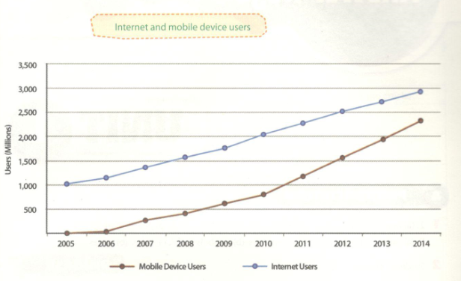
Gợi ý trả lời:
The line graph compares the number of Internet users with mobile device users during a period of nine years from 2005 to 2014.
As can be seen, the number of Internet users has been rising gradually from 2005. Starting from about 1,000 million users in 2005, the number of people using the Internet increased to just over 1,750 millions in 2009. Since then, the figure has risen at a faster and more stable pace, and as a result, the Internet now has some 2.9 billion users.
Similarly, the number of mobile device users has experienced a steep and constant upward trend for nine years. In the one-year period from 2005 to 2006, the figure remained at relatively the same level. However, over the next four years, the number of people who used mobile phones went up steadily from several millions to 800 millions in 2010. Since then, there has been a considerable growth in the number of users. The number of mobile device users today (in 2014) has reached 2.3 billion.
In conclusion, over the past nine years, both Internet and mobile device usage has increased. However, the substantial rise in the number of mobile device users shows that mobile devices are becoming more and more important.

