Pronunciation - trang 17 Unit 8 Sách Bài Tập (SBT) Tiếng anh 11 mới
Mark (rising intonation) or (falling intonation) on the choice questions in the following short exchanges.
Đánh dấu (tăng ngữ điệu) hoặc (giảm ngữ điệu) vào các câu hỏi lựa chọn trong các cuộc trao đổi ngắn sau đây.
1. A: Would you like to visit a natural or a cultural heritage site?
B: I'd like to see a natural one.
2. A: Do you prefer mountain climbing or cave exploring?
B: I prefer mountain climbing.
3. A: Would you like to go to Hue by car or by train?
B: Well, actually I prefer to go by plane.
4. A: Where would you like to go? To Ha Long Bay or toTrang An Scenic Landscape Complex?
B: I'd like to go to Ha Long Bay.
Đáp án:
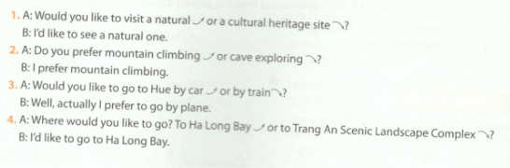
Vocabulary & Grammar - trang 17 Unit 8 Sách Bài Tập (SBT) Tiếng anh 11 mới
1 Complete the following crossword puzzle.
Hoàn thành câu đố ô chữ dưới đây
Across
- the traditions, art, buildings and cultural achievements of a country that have existed for a long time and have great importance for the country
- a group of connected things, especially buildings, designed for a particular purpose
- complete, not damaged
- a series of rulers who are from the same family
- the act of keeping something in its original state or in good condition
- existing in nature
- very old and having existed for a very long time
- an object, a tradition, etc. from the past that still exists today
- related to the study of the past cultures by examining the remains of buildings and objects found in the ground
- different from other similar things in an interesting and attractive way
Down
11. the activity of digging in the ground for old buildings or objects which have been buried for a long time
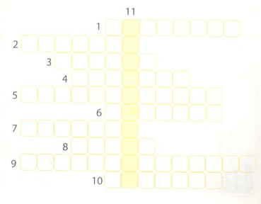
Đáp án:
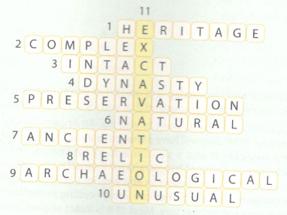
2 Use the correct form of the words in the box to complete each sentence.
Sử dụng đúng hình thức của các từ trong hộp để hoàn thành mỗi câu.
culture (n) excavate (v) geology (n) explore (v) architecture (n)
- Trang An Scenic Landscape Complex includes both natural and _______ sites.
- A lot of visitors to Phong Nha-Ke Bang National Park are keen on cave _______
- Phong Nha-Ke Bang National Park provides a lot of valuable information about the earth's _______development.
- Taj Mahal is considered to be a masterpiece of _______ style in design and construction technique
- The _______ will last for several years as scholars believe that there are still relics buried in this site
Đáp án:
1. cultural 2. exploration
3. geological 4. architectural 5. excavation
3. Complete the sentences with the correct form of the verbs in brackets.
Hoàn thành câu với đúng hình thức động từ trong ngoặc đơn.
- Here are some of the things _______ (avoid) when visiting a heritage site.
- Visitors should avoid shops _______ (sell) unusual relics from the area.
- Many of the items such as rings, key chains, or souvenirs are made of unusual shells or unique stones illegally _______ (remove) from the protected areas.
- If you buy stolen relics, you will help to create a black market, _______(lead) to further destruction of the heritage site.
- The final thing _______ (remember) is to admire the corals from a distance and not to break off any pieces to take home as souvenirs.
Đáp án:
1. to avoid 2. selling 3. removed 4.leading 5. to remember
4. Combine the two sentences into one, using either an -ing or -ed participle.
Kết hợp hai câu thành một, sử dụng phân từ -ing hoặc -ed.
1. A tour guide is taking us to Ha Long Bay. He can speak three languages.
The tour guide _______can speak three languages.
2. There's a gate at the end of this corridor. The gate leads to the main door of the temple.
At the end of this corridor there is a gate _______
3. The pagoda was damaged in the storm. It has now been rebuilt.
The pagoda _______ has now been rebuilt.
4. That man was selling unusual relics. They were illegally removed from the protected area of this heritage site.
That man was selling unusual relics _______
5. The Taj Mahal complex was recognised as a World Heritage Site in 1983. It includes the tomb, the mos the guest house, and the main gate.
The Taj Mahal complex, _______ , includes the tomb, the mosque, the guest house, and the main gate.

Gợi ý đáp án:
- The tour guide taking us to Ha Long Bay can speak three languages.
- At the end of this corridor there is a gate leading to the main door of the temple.
- The pagoda damaged in the storm has now been rebuilt.
- That man was selling unusual relics illegally removed from the protected area of this heritage site.
- The Taj Mahal complex, recognised as a World Heritage Site in 1983, includes the tomb, the mosque, the guest house, and the main gate.
Reading - trang 19 Unit 8 Sách Bài Tập (SBT) Tiếng anh 11 mới
1. Read a text about Ha Long Bay, a World Heritage Site in Vietnam, and choose the best title.
Đọc văn bản về Vịnh Hạ Long, Di sản Thế giới tại Việt Nam, và chọn tiêu đề tốt nhất.
A. Why Ha Long Bay was recognised as a World Heritage Site
B. Attractions in Ha Long Bay
C. Threats to Ha Long Bay and possible solutions
Recognised as a World Heritage Site in Viet Nam, Ha Long Bay attracts thousands of visitors every year, who come to enjoy its magnificent natural landscape. However, the bay is also facing a number of threats that may lead to serious damage to the site.
Wildlife in Ha Long Bay is being destroyed by overfishing as this is the only job to support most of the inhabitants here. As a result, rare sea creatures may become extinct soon.
Another problem is deforestation of mangrove forests. The mangroves, known as the plants native to Ha Long Bay, provide protection during storms, preserve the shoreline, and act as a natural filter that keeps the sea environment clean and healthy. Numerous wildlife species including plants and fish also depend on the mangroves.
What is more, some markets in Ha Long Bay sell unusual relics and natural objects, such as coral pieces, sea shells, or unique stones, probably illegally removed from the protected areas. Many of these items, converted into rings, key chains, and other souvenirs, are purchased by unsuspecting tourists. Buying these items creates a black market leading to further destruction of Ha Long Bay.
As eco-tourists, we can help to protect Ha Long Bay for future generations in several ways. For example, by sailing or fishing with the fishermen, we can share the benefits of tourism with the local community. This will help them to increase their income and reduce excessive fishing. We can also help local people to learn about the significance of the mangrove forests and help them to replant the mangroves. We should also avoid purchasing unusual souvenirs. As responsible tourists, we can discourage suspected traders or vendors by refusing to buy their illegal goods.
Đáp án:
Tiêu đề phù hợp nhất là C. Threats to Ha Long Bay and possible solutions
Các mối đe dọa đến Vịnh Hạ Long và giải pháp khả thi
2. Read the text again and answer the following questions.
Đọc lại văn bản và trả lời các câu hỏi sau.
- What is the environmental impact of overfishing?
- How important are the mangroves?
- What is the problem with buying unusual objects?
- What are the benefits of sailing or fishing with the local fishermen?
Gợi ý đáp án:
- Rare sea creatures may become extinct.
- They provide protection during storms, preserve the shoreline, and act as a natural filter that keeps the sea environment clean and healthy. Many wildlife species including plants and fish also depend on the mangroves.
- The unusual relics are probably illegally removed from the protected areas.
- The local fishermen can share the benefits of tourism and this will help them to increase their income and reduce excessive fishing.
Speaking - trang 20 Unit 8 Sách bài tập (SBT) Tiếng anh 11 mới
1 Choose the best option to complete the following sentences.
Chọn tùy chọn tốt nhất để hoàn thành các câu sau đây.
1. I suggest ______
A. visit Thien Mu Pagoda
B. to visit Thien Mu Pagoda
C. visiting Thien Mu Pagoda
2, How about ______ ?
A. explore Paradise Cave
B. exploring Paradise Cave
C. to explore Paradise Cave
3. Why don't we ______?
A. go there by train
B. to go there by train
C. going there by train
4. Let's ______
A. seeing the relics from the excavation site
B. to see the relics from the excavation site
C. see the relics from the excavation site
5. How do you feel about ______ ?
A. climb the highest mountain in the area
B. climbing the highest mountain in the area
C. to climb the highest mountain in the area
Đáp án:
1.C 2. B 3. A 4. C 5. B
2 Number the sentences in the correct order to make a conversation.
Đánh số các câu đúng thứ tự để thực hiện cuộc trò chuyện.
a.Well, it sounds interesting. How should we get there?
b. But Hue is so far away from here, and we only have two days. I'm afraid we will spend most of the time travelling. Why don't we visitTrang An Scenic Landscape Complex?
c. It is both a natural and cultural site, so there will be something for everyone to see.
d. There is a coach which starts at six in the morning. It can take us right to the site.
e. I'd like to suggest visiting the Complex of Hue Monuments. There are a lot of things to do and to see there
f. What's special about this heritage site?
g.OK, let's suggest this site to our class teacher. I hope he likes the idea.
h.Where shall we go on our next field trip?
Đáp án:
1.h 2. e 3. b 4. f 5.c 6. a 7.d 8. g
3 Work in pairs. Make a similar conversation to decide on the heritage site you both want to visit.
Làm việc theo cặp. Thực hiện một cuộc trò chuyện tương tự để quyết định địa điểm di sản mà cả hai bạn muốn ghé thăm.
Writing - trang 21 Unit 8 Sách Bài Tập (SBT) Tiếng anh 11 mới
1. Match the reasons why visitors want to visit Hoi An Ancient Town with the details to support them.
Nối lý do tại sao du khách muốn thăm Phố cổ Hội An với các chi tiết để hỗ trợ chúng.
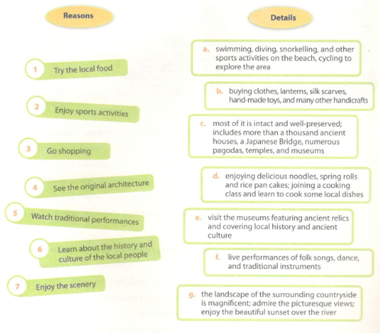
Đáp án:
1 d 2. a 3. b 4.c 5.f 6.e 7.g
2. Write a letter (160-200 words) about the reasons why visitors want to go to Hoi An, using the information in and your own ideas.
Viết một lá thư (160-200 từ) về lý do tại sao du khách muốn đến Hội An, sử dụng thông tin và ý tưởng của riêng bạn.
Gợi ý đáp án:
Dear Peter,
I was so excited when I received your letter yesterday. It is great that you're planning to visit one of the World Heritage Sites in Viet Nam next month. I recommend that you visit Hoi An Ancient Town.
In fact, there are a number of reasons why tourists want to visit Hoi An Ancient Town - one of the eight World Heritage Sites in Viet Nam. First of all, they will have a chance to try some local food such as delicious noodles and spring rolls. Going shopping is also a popular activity for visitors. They can buy clothes, lanterns, silk scarves, hand-made toys, and a lot of handicrafts for themselves as well as their friends and family. Moreover, people visiting Hoi An Ancient Town can enjoy various activities like swimming, diving, snorkelling, and other sports activities on the beach.They can also go cycling to explore the area. However, Hoi An's biggest attraction is its traditional architecture. Most of it is intact and well-preserved. There are more than a thousand ancient houses, a Japanese Bridge, numerous pagodas, temples, and museums. For all these reasons, Hoi An Ancient Town has become a popular destination for many visitors.
So, I hope I can show you all the interesting sights in Hoi An. Please let me know when you arrive, so I can pick you up at the airport.
Look forward to seeing you soon!
Best wishes,
Ha

