Pronunciation - trang 33 Unit 10 Sách Bài Tập (SBT) Tiếng anh 11 mới
1. Practise reading aloud the following questions with fall-rise intonation.
Thực hành đọc to những câu sau với ngữ điệu tăng-giảm
- Some more brown rice?
- She's been practising t'ai chi?
- Would you like to join our meditation group?
- I doubt if traditional medicine works.
- Are these the principles of staying healthy?
Đáp án:
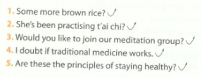
2 Mark (fall-rise intonation) at the end of the statements or questions where appropriate. Then practise with a partner.
Đánh dấu (ngữ điệu tăng giảm) vào cuối nhận định hoặc câu hỏi khi phù hợp. Sau đó, thực hành với một người bạn.
1. A: Would you like more coffee?
B: No, thanks. Can I have a glass of water, please?
2. A: Should I practise yoga?
B: Sure. It can help you to relieve your stress.
3. A: What is the first principle of a healthy lifestyle?
B: I'm not sure about it.
4. A: How about trying some natural remedies?
B: Well, they may be good for some minor illnesses.
5. A: Excuse me, are you waiting to see the doctor?
B: Yes. And I've been waiting for 15 minutes.
Đáp án:
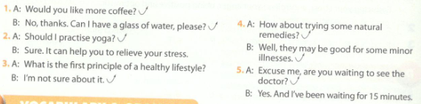
Vocabulary & Grammar - trang 33 Unit 10 Sách Bài Tập (SBT) Tiếng anh 11 mới
1. Complete the following sentences, using the correct form of the words in the box.
Hoàn thành các câu sau, sử dụng đúng hình thức của từ trong hộp.
prescribe
nutrition
immune
expect
meditate
health
- The development of effective medicines has contributed to the increase in the average life _______ in some countries.
- An hour of _______ can help you to relieve your stress.
- Doctors should use more legible handwriting when giving _______
- Some people believe that keeping a diary of daily activities is one simple way to help you to stay_______
- My doctor said that these natural remedies can boost my _______system.
- One of the main responsibilities of a dietitian is to promote _______ and balanced diets.
Đáp án:
1 .expectancy 2. meditation 3. prescription 4.healthy 5. immune 6. nutritious
2 Complete the following sentences, using the words from the box combined with -free or anti-.
Hoàn thành các câu sau đây, sử dụng các từ từ hộp kết hợp với -free hoặc anti-.
ageing stress cholesterol acne sugar
1. ________drinks are better for your teeth and general health.
2. In addition to a nutritious diet, a ________ lifestyle can boost your health and increase your life expectancy.
3. Some people believe that ________ foods can make them younger.
4. Home-made ________ masks based on fruits are completely natural and inexpensive.
5. People at a higher risk of heart disease should follow a________ diet.
Đáp án:
1 .Sugar-free 2. stress-free 3. anti-ageing
4.anti-acne 5.cholesterol-free
3 Report each statement. Make changes, if necessary.
Tường thuật lại mỗi câu. Thay đổi nếu cần thiết
1. ‘If you go to bed on an empty stomach, you won't be able to sleep well.’
Tom's father told him.............
2. ‘If you work too much and don't rest, you will weaken your immune system.'
My mother warned me that............
3. ‘If you follow my advice, your health will be much better.’
Ann's doctor told her that............
4. ‘If children don't get enough calcium, they won't grow strong and healthy bones.'
My grandmother explained that............
5. ‘If I consumed a lot of fast food, I could become overweight.'
Alice said that............
Đáp án:
- Tom's father told him if he goes to bed on an empty stomach, he won't be able to sleep well.
- My mother warned me that if I work too much and don't rest, I will weaken my immune system.
- Ann's doctor told her that if she follows his / her advice, her health will be much better.
- My grandmother explained that if children don't get enough calcium, they won't grow strong and healthy bones.
- Alice said that if she consumed a lot of fast food, she could become overweight.
4 Write the sentences in reported speech, using the reporting verbs and to-infinitive or -ing clauses.
Viết các câu gián tiếp, sủ dụng động từ tường thuật và to-V hoặc mệnh đề -ing
- ‘Don't forget to take your medicine regularly/ Quan s father said. ^{r}e^{r}rnded)
- ‘You need to have a health check-up every six months,* Peter's doctor said. (suggested)
- ‘You should eat less fast food and more vegetables,’ Jim's friend said. (advised)
- ‘You must practise these relaxation techniques every day to improve your health,’ Alice's yoga instructor said. (insisted on)
- ‘You should not go out if air pollution levels are very high,’ Kevin's doctor said, (warned)
- ‘I'm very sorry for not following your instructions,’ John said to his doctor. (apologised for)
Gợi ý đáp án:
- Quan's father reminded him to take his medicine regularly.
- Peter's doctor suggested that he should have a health check-up every six months.
- Jim's friend advised him to eat less fast food and more vegetables.
- Alice's yoga instructor insisted on her practising those relaxation techniques every day to improve her health.
- Kevin's doctor warned him not to go out if air pollution levels are very high.
- John apologised for not following his doctor's instructions.
5 Change the sentences in reported speech into direct speech.
Chuyển các câu từ dạng trực tiếp sang gián tiếp
- My brother promised to stop over-exercising and spend more time studying.
- Tom's dentist advised him to brush his teeth after meals and before bedtime.
- David's yoga instructor invited him to attend their course on meditation.
- The swimming instructor warned the children not to jump into the pool off the high diving boards.
- The students agreed to do a workout every morning.
- Alice apologised for missing the seminar on life expectancy factors.
Gợi ý trả lời:
- My brother said, ‘I will stop over-exercising and spend more time studying.’
- Tom's dentist said, ‘You should brush your teeth after meals and before bedtime.'
- ‘You should attend our course on meditation,’ David's yoga instructor said.
- The swimming instructor told the children, ‘Don't jump into the pool off the high diving boards.’
- ‘We will do a workout every morning,’ the students agreed.
- Alice said, ‘I'm sorry for missing the seminar on life expectancy factors.’
Reading - trang 35 Unit 10 Sách Bài Tập (SBT) Tiếng anh 11 mới
1. Read the text and answer the questions.
Đọc văn bản và trả lời các câu hỏi
Changing lifestyles for better health
As a way of living, lifestyle is everyday behaviours, activities, and diet. It involves your work, leisure activities, food and drink consumption, and interaction with people. That is why it is important to have a healthy lifestyle. Although it is often difficult to change your habits, reorganising your daily activities to achieve a healthy lifestyle is not impossible. Here are some steps you need to take to have a better life and health.
Become more active
Scientists have proved that regular exercise can help to reduce cholesterol and the risk of heart disease. Remember that you do not need to do too much exercise - just a 30-minute walk a day will bring health benefits. But it is important that you do it regularly and safely. Simple things like walking or cycling to school, using the stairs instead of the lift, doing the housework and gardening can all contribute to good health.
Moreover, hobbies such as dancing, reading, listening to music, playing chess, and solving crossword or sudoku puzzles are also good ways to keep your body and mind engaged, and increase life expectancy. No matter where you are - at home, at work, or at play - always look for opportunities to be more active and energetic.
Eat healthily
‘Eat to live, not live to eat’ is the advice to follow.The food and drink we consume can dramatically affect our health. Bad nutrition based on fast food, and meals high in fat and sugar can lead to obesity, diabetes, some types of cancer and other chronic diseases. Planning and following a healthy and balanced diet is not difficult at all. Eat the right amount of calories to balance the energy you get from food and the energy you use. Make sure you have a wide range of foods to receive all the nutrients you need. Remember to eat less saturated fat, sugar and salt, and more fish, fruit, and vegetables.
Stay positive and be happy
Once you have started to be more active and eat more healthily, you can notice that you also feel happier. There is no doubt that daily worrying and stress can damage your heart and brain. When you are under a lot of stress, you may get angry easily. Anger and hostility have negative effects on the cardiovascular system. Recent research has confirmed that angry, hostile people live a shorter life. Try to control your anger, always look at the positive side of every situation and be optimistic. If necessary, practise sor-e meditation and yoga to help you to relieve your stress and anger, and enjoy life more.
Questions
- Why is lifestyle an important factor for healthy living?
- What lifestyle changes does the writer recommend?
- What are the benefits of regular exercise?
- How can you keep your body and mind active?
- What are the main principles of healthy eating?
- What is the key to happier living?
Gợi ý trả lời:
- Because it involves one's work, leisure activities, food and drink consumption, and interaction with people.
- Becoming more active, eating more healthily, and staying positive and happy.
- It can help to reduce cholesterol and the risk of heart disease.
- By having hobbies such as dancing, reading, listening to music, playing chess, and solving crossword or sudoku puzzles.
- Eating the right amount of calories and a wide range of foods to receive all the nutrients the body needs, and consuming less saturated fat, sugar and salt, and more fish, fruit, and vegetables.
- Reducing your stress, controlling your anger, being positive and optimistic.
2 Match each of the words with its meaning. Use a dictionary, if necessary.
Nối từ với nghĩa của nó. Sử dụng từ điển, nếu cần
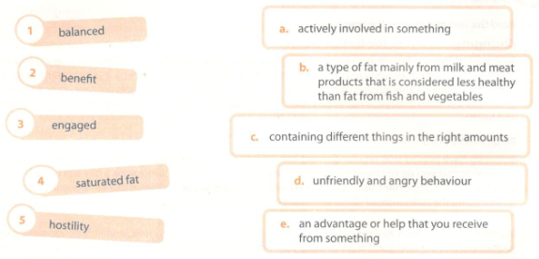
Đáp án:
1. c 2. e 3. a 4. b 5.d

3 Read the text again. Decide whether the following statements are true (T), false (F), or not given (NG). Tick the boxes.
Đọc lại văn bản. Quyết định xem các câu sau có đúng (T), sai (F), hay không xác định (NG). Đánh dấu các ô.
- It is not possible to change your daily habits and activities.
- In order to reduce cholesterol, you need to exercise a lot and work out more than 30 minutes every day.
- Physical activity should be done not just regularly, but safely.
- Although fast food may lead to obesity, it has some definite advantages.
- You should consume less fat and more sugar to balance the energy you use with the energy that goes into your body.
- Stress and anger can affect people's life expectancy negatively.
Đáp án:
1.F 2. F 3.T 4.NG 5. F 6.T
Speaking - trang 37 Unit 10 Sách bài tập (SBT) Tiếng anh 11 mới
1. Work with a partner. Match the tips with the reasons. Then practise asking and answering questions about the tips on how to take good care of your teeth.
Làm việc cùng người bạn. Nối các mẹo với các lý do. Sau đó thực hành hỏi và trả lời các câu hỏi về các lời khuyên về cách chăm sóc tốt răng của bạn.
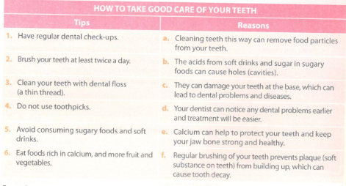
Đáp án:
1.d 2.f 3.a 4.c 5. b 6.e
2 Work in groups of four. Use the information in 1 to prepare a set of note cards for a talk about how to take good care of your teeth. Take turns to present your talk to your group members.
Làm việc theo nhóm bốn người. Sử dụng thông tin trong phần 1 để chuẩn bị một bộ thẻ lưu ý để thảo luận về cách chăm sóc răng tốt. Thay phiên nhau trình bày bài nói chuyện của bạn với các thành viên trong nhóm của bạn.
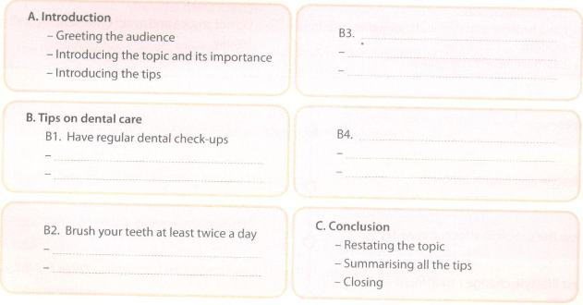
Writing - trang 38 Unit 10 Sách Bài Tập (SBT) Tiếng anh 11 mới

1. Use the information in the table to write sentences about how lifestyle affects health.
Sử dụng thông tin trong bảng để viết câu về lối sống ảnh hưởng đến sức khoẻ.
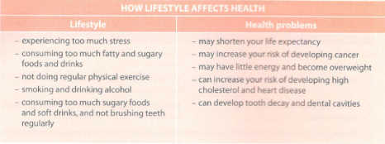
Gợi ý:
- If you consume too much fatty and sugary foods and drinks, you will increase your risk of developing high cholesterol and heart disease.
- If you do not do physical exercise regularly, you may have little energy and become overweight.
- If you smoke and drink alcohol, you may increase your risk of developing cancer.
- If you consume too much sugary foods and soft drinks, and do not brush you. teeth regularly, you can develop tooth decay and dental cavities.
2. Choose one lifestyle and health problem from and suitable suggestions from the box below to write a story about how a teenager has changed his / her lifestyle to overcome a health problem. Prepare an outline for your writing.
Chọn một lối sống và vấn đề sức khoẻ từ những gợi ý thích hợp từ hộp dưới đây để viết một câu chuyện về cách một thiếu niên đã thay đổi lối sống của mình để vượt qua vấn đề sức khoẻ. Chuẩn bị một dàn ý cho bài viết của bạn.
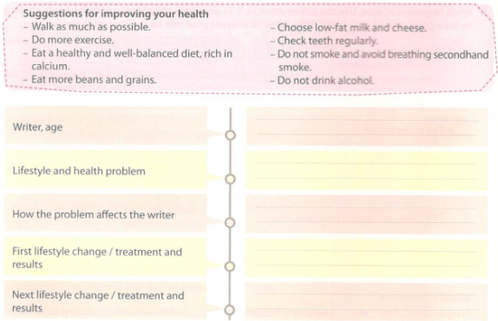
Gợi ý trả lời:
My name is Tom and I am 18 years old. I used to eat a lot of sugary foods like sweets, chocolate, and biscuits, and I started having toothaches very often and developed some tooth cavities. At first I didn't pay much attention, but on several occasions the toothache became terrible and lasted more than a week. I could not focus on my studies and sometimes I could not sleep well. I took some medicine to relieve the pain, but this didn't help much. As a result, my first term grades were really poor. I decided that I needed to deal with this problem.
I've always hated going to the dentist, but I finally took the courage. She checked my teeth, filled all the cavities and cleaned my teeth. Although I had to make a few visits to the dentist and the treatments were really uncomfortable, the results were great! She also gave me some advice on how to keep my teeth healthy. She recommended eating a healthy and well-balanced diet with foods rich in calcium, avoiding sugary foods and drinks, brushing my teeth at least twice a day, and having my teeth checked every three months. At first, it was a bit difficult for me to follow her advice and give up sweets and chocolate. But I didn't want to experience more toothaches and I knew the importance of healthy teeth.
I'm now eating a healthy diet, brushing my teeth three times a day and don't eat sweets or chocolate every day. My grades have improved and I am now preparing for university entrance examinations. Can you guess my major? It's dentistry!

