UNIT 1. WHAT’S YOUR ADDRESS?
- Translate intoEnglish:
1. thành phố:.............................6. tòa tháp:................................11. núi:.............................................
2. ngôi làng:..............................7. tầng:......................................12. đất nước:...................................
3. tỉnh:.......................................8. đường phố:............................13. yênbình:....................................
4. thị trấn:..................................9. quê hương:............................14. đôngđúc:...................................
5. địa chỉ:...................................10. vùng quê: .............................15. bận rộn, tấpnập:........................

- Use the words in EXERCISEI to complete thesentences:
  - Quang Nam ………………..……….. is my father’shometown.
  - My aunt and uncle live in a small ………………..……….. in thecountryside.
  - Her family lives on the third ………………..……….. of HAGL Tower.
  - There is a big and tall ………………..……….. in front of myhouse.
  - Danang is one of the most beautiful ………………..……….. inVietnam.
  - Their ………………..……….. is 97B, Nguyen Van Cu Street.
  - Truong Son is the longest ………………..……….. in mycountry.
  - Peter’s ………………..……….. is London City inEngland.

- Look andcomplete:



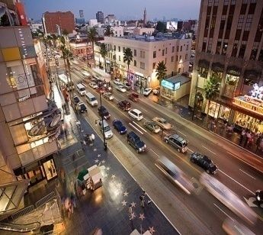
1. v i _ _ ag_ 2. m _ u n t _ i__ 3. t__e_ 4.a_en_e
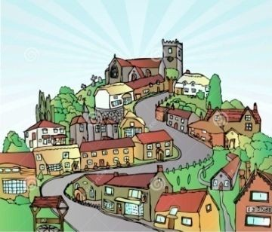
5. _ it_ 6. t _w_ 7. _ s _ an _ 8.s_re_m

- Match the words that have oppositemeaning:
1. old | a. tall | 1.
2. small | b.countryside | 2.
3. far | c. noisy | 3.
4. short | d.near | 4.
5. early | e. large | 5.
6. city | f.late | 6.
7. quiet | g. modern | 7.
- Put the words in order to makesentences:
  - address / What/ Mai’s/ is?
.....................................................................................................................................................
  - does / she/ Who/ with / live?
.....................................................................................................................................................
  - her/ Is/ house/beautiful?
.....................................................................................................................................................
  - 56 Nguyen Trai/ is / Street/It.
.....................................................................................................................................................
  - she/ Where/ does/live?
.....................................................................................................................................................
  - Danang/ hometown/ His/ city/is.
.....................................................................................................................................................
  - hometown/ like/ What/ his/is?
.....................................................................................................................................................
  - small/ quiet/ village/ and/ It/is.
.....................................................................................................................................................
  - you/ Do/ your/ live/ with/parents?
.....................................................................................................................................................
  - are/ modern/ There/ towers/ my/ in/town.
.....................................................................................................................................................

- Translate intoEnglish.
- Địa chỉ của bạn làgì?
.....................................................................................................................................................
- Bạn sống cùng vớiai?
.....................................................................................................................................................
- Quê của bạn ởđâu?
.....................................................................................................................................................
- Quê của bạn trông như thếnào?
.....................................................................................................................................................
- Bạn có sống cùng với ông bàkhông?
.....................................................................................................................................................
- Địa chỉ của anh ấy làgì?
.....................................................................................................................................................
- Anh ấy sống cùng vớiai?
............................................
- Quê của anh ấy ởđâu?
..................................................................................................................................................... 9.Côấysốngởmộtngôilàngnhỏởvùngquê.
.........................................................................................................................................
10.Làng của cô ấy nhỏ và yên bình.
.....................................................................................................................................................

- Odd oneout:
1. a. city | b. town | c. flat | d. province
2. a. house | b. far | c. near | d. modern
3. a. lane | b. street | c. stream | d. avenue
4. a. orange | b. bread | c. buildings | d. noodles
5. a. how | b. village | c. where | d. who
6. a. small | b. quiet | c. noisy | d. centre
7. a. like | b. jump | c. skip | d. dance
8. a. island | b. sea | c. fish | d. factory
9. a. crowded | b. countryside | c. noisy | d. modern
10.a. pretty | b. bad | c. nine | d. beautiful

