Pronunciation - trang 34 Unit 5 Sách Bài Tập (SBT) Tiếng anh 11 mới
1 Practise saying the following sentences. Mark the intonation: rising or falling.
Thực hành nói những câu sau đây. Đánh dấu ngữ điệu: tăng hoặc giảm.
1 | Is Viet Nam on the Indochinese Peninsula?
2 | Viet Nam shares borders with China, Laos and Cambodia.
3 | Ho Chi Minh City is one of the biggest cities in Viet Nam.
4 | Is Vietnamese the official language of Viet Nam?
5 | There are 54 ethnic groups living in Viet Nam.
Đáp án:
Rising intonation: 1,4 Falling intonation: 2, 3, 5
2 Practise reading aloud the following sentences, using suitable intonation.
Tập đọc to các câu sau, sử dụng ngữ điệu phù hợp.
- Most of the mineral resources of Viet Nam are in the north.
- Is the majority of the Vietnamese population engaged in agricultural work?
- The Mekong and the Red River Deltas are big rice-growing areas.
- Is the culture of Viet Nam one of the oldest in the region?
- Dragons and turtles are important symbols in Vietnamese culture.
Vocabulary & Grammar - trang 35 Unit 5 Sách Bài Tập (SBT) Tiếng anh 11 mới
1. Look for the names of five more ASEAN countries in the word puzzle. Write them down in the spaces below.
Hãy tìm tên của năm nước ASEAN khác trong câu đố chữ. Viết chúng xuống trong các không gian dưới đây.
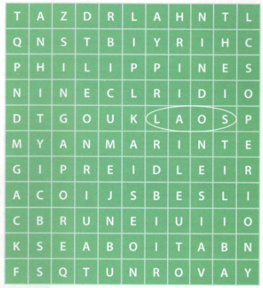
Đáp án:
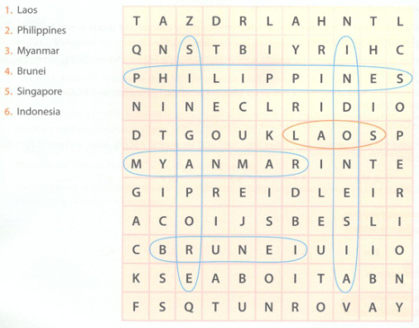
2. Complete the sentences with the words in the box.
Hoàn thành các câu với các từ trong hộp.
cooperation
identity
association
stability
constitution
motto
- The ________ of Viet Nam is "Independence - Freedom - Happiness".
- Being a regional ________ for many years, ASEAN is now striving for greater integration.
- The ASEAN member states decided to launch its charter when they recognised the need for a ________ .
- The ASEAN Charter helps to define the bloc's ________ in the region.
- ASEAN members aim to build a friendly and united community promoting________ , peace and development.
- There are measures to strengthen economic________between ASEAN member states.
Đáp án:
1. motto 2. association 3. constitution
4. identity 5.stability 6. cooperation
measures to strengthen economic

3. Match 1 -6 with a-f to make meaningful sentences.
Nối 1-6 với a-f để tạo các câu có ý nghĩa.
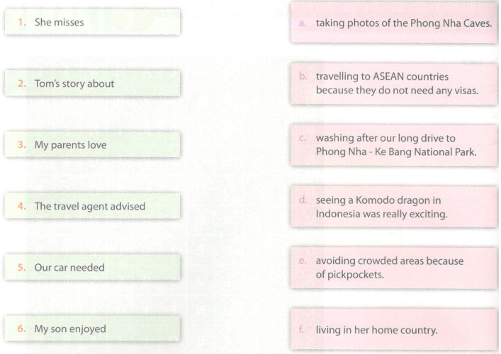
Đáp án:
1.f 2.d 3.b 4. e 5. c 6. a

4. Use the present simple or continuous form of the verbs in brackets to complete the sentences.
Sử dụng thì hiện tại đơn hoặc hiện tại tiếp diễn của các động từ trong ngoặc đơn để hoàn thành câu.
- We___________ (have) a good time at the concert to welcome the delegation of ASEAN officials.
- My classmates___________ (want) to participate in the competition on ASEAN held at school.
- I___________ (love) dancing Lamvong, the national folk dance of Laos.
- The ASEAN countries___________ (wish) to promote economic growth, social progress and cultural development.
- Look! Lan___________ (smell) the flowers her boyfriend sent her from Da Lat.
- We___________ (think) of spending our holiday in Kuala Lumpur, Malaysia.
Đáp án:
1. are having 2.want 3. love
4. wish 5. is smelling 6. are thinking
5 Underline the wrong verb tense or form and correct the mistake.
Gạch dưới thì hoặc hình thức động từ sai và sửa lỗi.
1. I like Thai food. It is tasting delicious.
2. The students see their teacher this afternoon to discuss the ASEAN Week at school.
3. Tuan is thinking that being an ASEAN member is important for the development of Viet Nam.
4. Now Nam looks at the documents, trying to find answers to the questions about ASEAN.
5. I'm not sure now. I have second thoughts about studying in Singapore.
6. Two students from our class succeeded in win prizes in the competition on ASEAN and the ASEAN Charter.
Đáp án:
1. | is tasting —► tastes | 2. | see —► are seeing
3. | is thinking —► thinks | 4. | looks—► is looking
5. | have —► am having | 6. | win —► winning
Reading - trang 37 Unit 5 Sách Bài Tập (SBT) Tiếng anh 11 mới
1. Read the following text about the ASEAN Para Games. Match each paragraph with its heading.
Đọc các văn bản dưới đây về các Hiệp định Para Games của ASEAN. Nối từng đoạn với tiêu đề của nó.
Paragraph A
Paragraph B
Paragraph C
Paragraph D
Paragraph E
- The 7th ASEAN Para Games
- History of the ASEAN Para Games
- ASEAN and its activities
- Objectives of the ASEAN Para Games
- Viet Nam's team at the 7th ASEAN Para Games
A. Formed on August 8th 1967, the Association of Southeast Asian Nations (ASEAN) was originally a group of five countries. Nowadays, ASEAN is a united bloc often countries, which promotes many cultural and sports events besides political and economic cooperation. The ASEAN Para Games for athletes with physical disabilities is a good example.
B. The ASEAN Para Games aims at promoting sports for people with disabilities in the region and increasing public awareness of disabled sports. Regional Para sports events offer opportunities for building friendship and cooperation among disabled people in ASEAN member states.
C. The ASEAN Para Games is held about every two years after the Southeast Asian Games (SEA Games) in an ASEAN member state.The first ASEAN Para Games took place in 2001 in Kuala Lumpur, Malaysia. This was the first major sports event of the ASEAN Para Sports Federation (APSF). The second ASEAN Para Games was organised in 2003 in Viet Nam. The third, fourth, fifth, and sixth ASEAN Para Games were held in the Philippines,Thailand, Malaysia and Indonesia respectively.
D. Athletes with disabilities from the ten ASEAN members and East Timor attended the 7th ASEAN Para Games in 2014 in Myanmar. They competed in 12 sports: archery, athletics, boccia, chess, football 5-a-side, football 7-a-side, goalball, powerlifting, swimming, table tennis, sitting volleyball and wheelchair basketball. Indonesia finished first andThailand, which had dominated the Games for more than a decade, dropped to the second place. Malaysia was third and Viet Nam retained the fourth position.
E. There were about 120 Vietnamese athletes at the 2014 ASEAN Para Games. They took part in six events. Even though the Vietnamese delegation was not among the top three, the 7th ASEAN Para Games could be considered a successful event for Viet Nam. The Vietnamese athletes with disabilities tried very hard and set several ASEAN, Asian and world Para Games records.
Đáp án:
A. 3 B. 4 C. 2 D. 1 E. 5
2 Find the words or expressions in the text that have the following meanings. Write each word or expression next to its meaning.
Tìm các từ hoặc các biểu thức trong văn bản có các ý nghĩa sau. Viết mỗi từ hoặc biểu hiện bên cạnh ý nghĩa của nó.
- support or encourage actively
- control or influence someone or something
- keep or continue to have something
- go to an event such as a meeting or sports competition
- a group of people who represent a country, company or organisation
Đáp án:
1. promote 2. dominate 3. retain
4. attend 5. delegation
3 Read the text again and answer the questions.
Đọc văn bản lại lần nữa và trả lời các câu hỏi
- What was ASEAN when it was formed on August 8th 1967?
- What is ASEAN now?
- What does the ASEAN Para Games aim at?
- How often is the ASEAN Para Games held?
- When and where did the first ASEAN Para Games take place?
- Why was the 7th ASEAN Para Games a successful event for Viet Nam?
Đáp án:
- It was originally a group of five countries.
- It is a united bloc of ten countries, which promotes many cultural and sports events besides politic and economic cooperation.
- It aims at promoting sports for people with disabilities in the region and increasing public awarene of disabled sports.
- The Games is held about every two years after the Southeast Asian Games (SEA Games) in an ASE/ member country.
- The Games took place in 2001 in Kuala Lumpur, Malaysia.
- Because the athletes with disabilities tried hard and set several ASEAN, Asian and world Para Gam records.
4. Based on the information in the text, decide whether the following statements are true (T), false (F), or not given (NG). Tick the boxes.
Dựa trên thông tin trong văn bản, hãy quyết định xem các câu sau đây là đúng (T), sai (F), hay không xác định (NG). Đánh dấu vào các ô.
- Regional Para sports events offer opportunities for building friendship and cooperation among people with disabilities in ASEAN member countries.
- Participating in sports events, people with disabilities also have a chance to find their lifetime partners.
- APSF is in charge of organising the ASEAN Schools Games.
- The second ASEAN Para Games took place in 2005 in Viet Nam.
- Disabled athletes from the 11 ASEAN member states attended the 7thASEAN Para Games in 2014 in Myanmar.
- Archery, athletics, boccia, chess, football 5-a-side, football 7-a-side, goalball, powerlifting, swimming, table tennis, sitting volleyball and wheelchair basketball were the sports events at the 2014 ASEAN Para Games.
Đáp án:
1.T 2.NG 3. F 4. F 5. F 6.T
Speaking - trang 40 Unit 5 Sách bài tập (SBT) Tiếng anh 11 mới
1. Complete the following medal table of the ASEAN Para Games, using the appropriate words or numbers.
Hoàn thành bảng huy chương sau của ASEAN Para Games, sử dụng các từ hoặc số thích hợp.
a. Myanmar b. Thailand (256) c. (96) d. Philippines e. (126) f. Thailand (130)
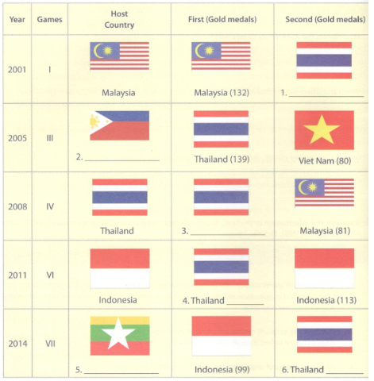
Đáp án:
1.f 2. d 3. b 4. e 5. a 6. c
2 Work in pairs. Talk about two ASEAN Para Games, using the information in the medal table in 1.
Làm việc theo cặp. Nói về hai trò chơi Para Games của ASEAN, sử dụng thông tin trong bảng huy chương trong bài 1.
Example:
Student A: When and where did the third ASEAN Para Games take place?
Student B: It took place in 2005 in Philippines.
Student A: Which country was first and which country was second?
Student B: Thailand finished first with 139 gold medals. Viet Nam was second with 80 gold medals.
Writing - trang 41 Unit 5 Sách Bài Tập (SBT) Tiếng anh 11 mới
1 Develop the following ideas into a short introduction about studying in Thailand. Add words or make changes, if necessary.
Phát triển những ý tưởng sau đây thành một phần giới thiệu ngắn về việc học tập tại Thái Lan. Thêm từ hoặc thay đổi, nếu cần.
Thailand
Country and People
- Known as/ ‘land of smiles’/ Thailand/ be/ ideal tourist attraction/ with/ pleasant tropical climate/ beautiful beaches/ picturesque mountains/.
- country/ also/ attract/ foreign students/ with/ its very high-quality education/ safety/ very low cost/ living/.
- Foreign students/ be made/ feel welcome/ hospitable locals/ many of whom speak English/ encourage foreigners/ speak Thai/.
Education
4. There/ be/ more/ 20,000 foreign students/Thai higher education institutions/ 2011/.
5. Most/ foreign students/ be/ from Asia/ with China, Myanmar/ Laos/ be/ top three countries/ send students/Thailand/.
6. International students/ travel/ Thailand/ study ecology/ environment/ agriculture/ economic development/.
Gợi ý trả lời:
Thailand
Country and People
- Known as the ‘land of smiles’, Thailand is an ideal tourist attraction with a pleasant tropical clima beautiful beaches and picturesque mountains.
- The country also attracts many foreign students with its very high-quality education, safety and a v< low cost of living.
- Foreign students are made to feel welcome by hospitable locals, many of whom speak English a encourage foreigners to speak Thai.
Education
4. There were more than 20,000 foreign students in Thai higher education institutions in 2011.
5. Most of the foreign students are from Asia, with China, Myanmar and Laos being the top three countries sending students to Thailand.
6. International students often travel to Thailand to study ecology, environment, agriculture and economic development.
2. Write a short introduction about studying in Malaysia, using the information below.
Viết một giới thiệu ngắn về việc học tập tại Malaysia, sử dụng thông tin dưới đây.
Malaysia
Country and People
- ranked 10th most-visited country, famous for natural beauty
- friendliness of people, diversity of cultures and languages: attract tourists from around the world
- foreign students say: feel comfortable, peaceful, safe to live and study in Malaysia
Education
- more than 90,000 international students (2011); country aims: attract at least 200,000 (coming years)
- ranked 11^{,h} (in terms of international students); top five countries sending students: Iran, Indonesia, China, Nigeria,Yemen
- international students: benefit from Malaysian excellent education system, get qualifications from country's famous universities
Gợi ý trả lời:
Malaysia
Country and People
- Ranked the 10th most-visited country in the world, Malaysia is famous worldwide for its natural beauty.
- The friendliness of the people, and diversity of cultures and languages attract a lot of tourists from around the world.
- Foreign students often say that they feel comfortable, peaceful and safe to live and study in Malaysia. Education
- In 2011, Malaysia had more than 90,000 international students. The country aims to attract at least 200.0 international students in the coming years.
- Malaysia is ranked 11th in terms of international students and the top five countries sending students to Malaysia are Iran, Indonesia, China, Nigeria and Yemen.
- Malaysia is ranked 11th in terms of international students. The top five countries sending students to Malaysia are Iran, Indonesia, China, Nigeria and Yemen.
- International students can benefit from the Malaysian excellent education system and get qualifications from the country's famous universities.

