A. Phonetics - trang 10 - Unit 2 – Sách bài tập(SBT) tiếng Anh 7 mới
1. Put the words on the left into their correct column.
Xếp các từ ở bên trái vào đúng cột.
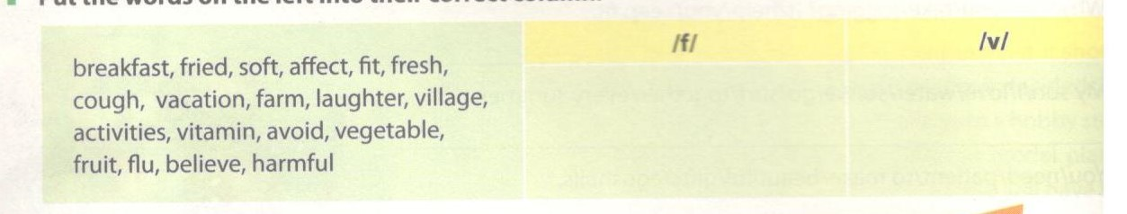
Key - Đáp án:
/f/ | /v/
breakfast, fried, soft, affect, fit, fresh, farm, laughter, fruit, flu, harmful, cough | avoid, vavation, village, activities, vitamin, vegetable, believe

2. Listen and underline the word you hear in each sentence.
Nghe và gạch chân từ bạn nghe được trong mỗi câu.
1. The fan/van is running fast.
2. Laughing/Loving is good for health.
3. Refer/River to exercise 3, page 24 of your textbook.
4. Half/Have is a verb.
5. Every day we take the ferry/very to school.
Key - Đáp án:
1. The fan/van is running fast.
2. Laughing./Loving is good for heait~
3. Refer/River to exercise 3, page 24 of yotr todteok.
4. Half/Have is a verb.
5. Every day we take the ferry/very to sAooL
Audio script:
1. The van is running fast.
2. Laughing is good for health.
3. Refer to exercise 3, page 24 of your textbook.
4. Have is a verb.
5. Every day we take the ferry to school.
3. Tongue Twister
Luyện lưỡi
Repeat this sentence five times. Say it as quickly as you can.
Lặp lại câu sau 5 lần. Nói càng nhanh càng tốt.
Fat frogs fly fast in the very vast velvet vault.
B. Vocabulary & Grammar – trang 10 – Unit 2 – Sách bài tập(SBT) tiếng Anh 7 mới
1. Underline the odd word/phrase in each group.
Gạch dưới những từ có nghĩa khác trong mõi nhóm
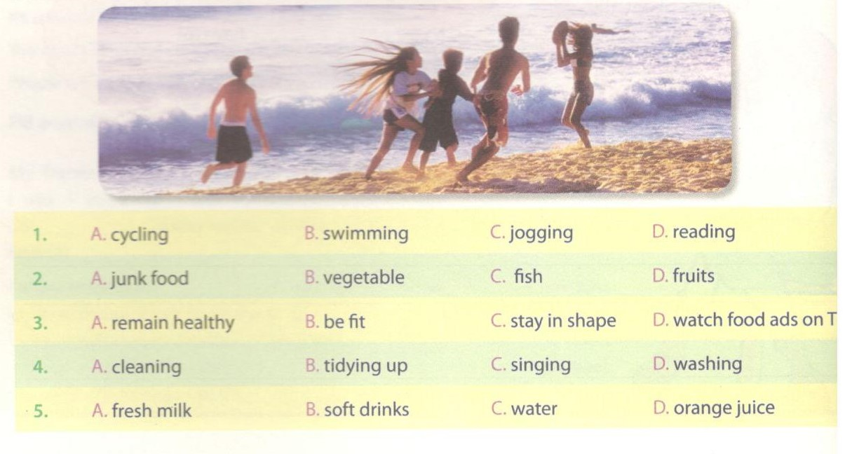
Key - Đáp án:
1.D; 2.A; 3.D; 4.C; 5.C
2. Put the words/phrases in the box into the correct column.
Xếp các từ/cụm từ trong hộp sau vào đúng cột.
spitting, junk food, rubbish, clean water, eating fast, sitting close to the TV, parks, fresh milk, exercising, low-fat food, dusty area, making noise, cleaning teeth, trees, littering.
Healthy... | Unhealthy...
Food and drinks
Activities
Environment

Key - Đáp án:
 | Healthy — | Unhealthy...
Food and drinks | low-fat food, fresh rrdk | junk food
Activities | exercising, deaning teeth | spitting, littering, eating fast, sitting close to the TV
Environment | clean water, parks, trees | rubbish, dusty area, making noise

3. Use the words/ phrases in 2 to fill in the sentences.
Sử dụng từ/ cụm từ trong bài 2 hoàn thành các câu sau.
1. Some people have a very bad habit of_____ in public. They throw used things anywhere.
2. It's harmful for your body if you eat a lot of____ .
3. _______ like running, playing ping pong can help you to stay in shape.
4. A public place should have a dust bin for people to throw________ in.
5. A good diet contains______ .
6. People who live in_______ often suffer from diseases.
Key - Đáp án:
1. littering; 2. junk food; 3. Exercising; 4. rubbish; 5. low-fat food; 6. dusty area
4. Look at the keywords and write the corresponding thing or activity in the column on the right. The first one is done as an example.
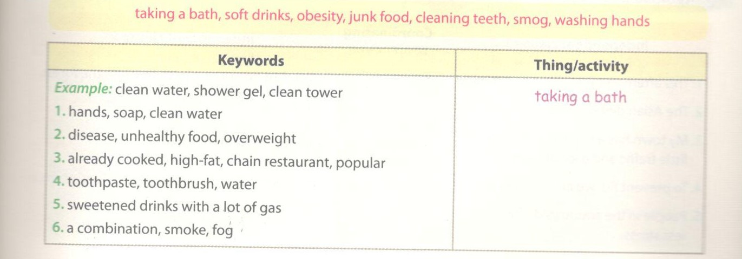
Key - Đáp án:
1. washing hand; 2. obesity; 3. junk food; 4. cleaning teeth; 5. soft drinks; 6. smog
5. Use the words in the box to fill in the text. You can use one word more than once.
Sử dụng các từ trong hộp để điền vào đoạn văn. Một từ có thể sử dụng hơn một lần.
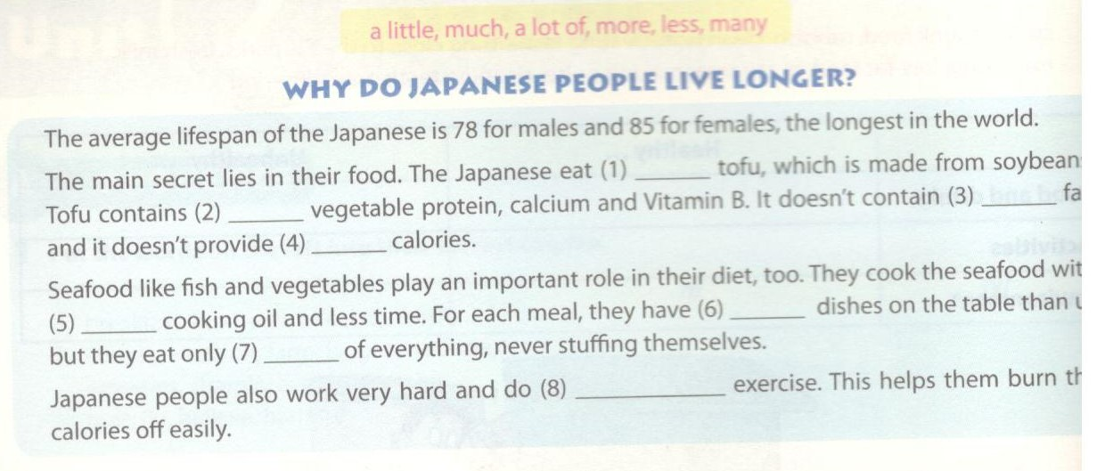
Key - Đáp án:
1.a lot of; 2. a lot of; 3. much; 4. many; 5. less; 6. more; 7. a little; 8. more
6. Match the beginnings in A with the endings in B.
Nối phần bắt đầu ở cột A với phần kết ở cột B.
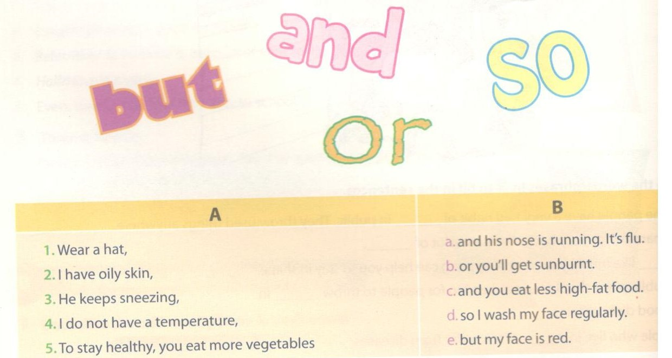
Key - Đáp án:
1.b; 2d; 3.a; 4.e; 5.c
7. Combine one independent clause 1 with the opposite independent clause 2 by using an appropriate coordinating conjunction.
Nối mệnh đề độc lập ở cột 1 với một mệnh đề độc lập ở cột 2 bằng cách sử dụng từ nối.
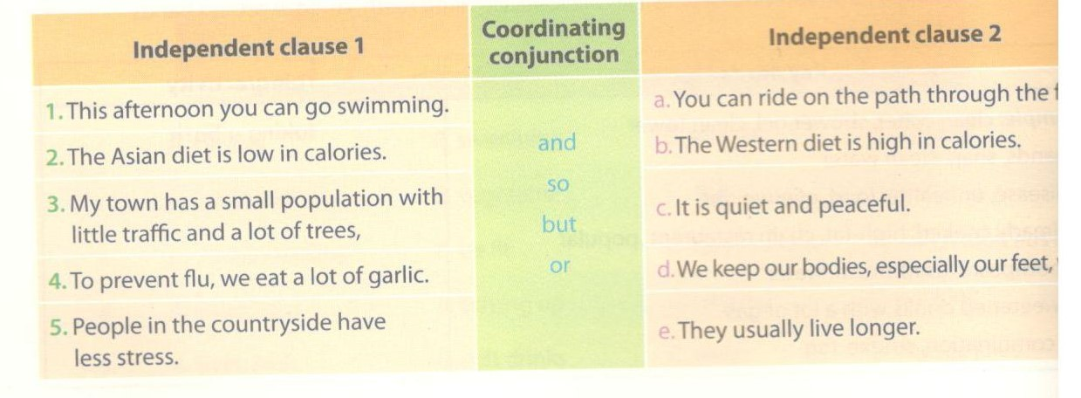
Key - Đáp án:
1 .This afternoon you can go swimming or you can ride on the path through the forest.
2. The Asian diet is low in calories, but the Western diet is high in calories.
3. My town has a small population with little traffic and a lot of trees, so it is quiet and peaceful.
4. To prevent flu, we eat a lot of garlic and we keep our bodies, especially our feet, warm.
5. People in the countryside have less stress, so they usually live longer.
C. Speaking – trang 12 – Unit 2 – Sách bài tập(SBT) tiếng Anh 7 mới.
1. Look at some sentences about how to stay healthy and happy. Tick ( P the ones you agree with and cross (x) the ones you don't.
Các câu dưới đây nói về cách để sống khỏe và hạnh phúc. Đánh dấu (P) nếu bạn đồng ý và dấu (x) nếu bạn không đồng ý.
1. Don't hate people. It makes you tired.
2. The more you laugh, the happier you are, and the longer you live.
3. Never play in the sun. It harms your skin.
4. Don't drink fresh milk. You will get fat.
5. The more calories you take, the better it is.
6. Clean water, fresh air, and a balanced diet are the causes of a long life.
2. Share your ideas with your partner and start conversations.
Chia sẻ ý kiến của bạn với bạn bè và bắt đầu cuộc hội thoại.
Example:
-! don't agree with sentence one.
-Why not?
- Because there are bad people and I cannot stop hating them.
3. Two people are talking about some common practices in Viet Nam. Put the sentences in the correct order.
Hai người đang nói về một vài bài tập chung ở Việt Nam. Điền thứ tự các câu sao cho đúng.
___ B: Why do they do that?
___ A: The fishermen in my village drink fish sauce before they get down to the sea.
__ B: It can prevent people from getting cancer.
___ A: Interesting. In my area we drink a lot of green tea.
_ A: Why green tea?
___ A: The sauce gives them strength to stand the cold in water.
Can you continue the conversation with another practice you know?
Key - Đáp án:
A: The fishermen in my village drink fish sauce before they get down to the sea. B: Why do they do that?
A: The sauce gives them strength to stand the cold in water.
B: Interesting. In my area we drink a lot of green tea.
A: Why green tea?
B: It can prevent people from getting cancer.
D. Reading - trang 13 – Unit 2 – Sách bài tập( SBT) tiếng Anh 7 mới
1. Here are some pieces of advice for you. Put them in the correct categories.
Dưới đây là một vài lời khuyên cho bạn. Xếp chúng vào đúng loại.
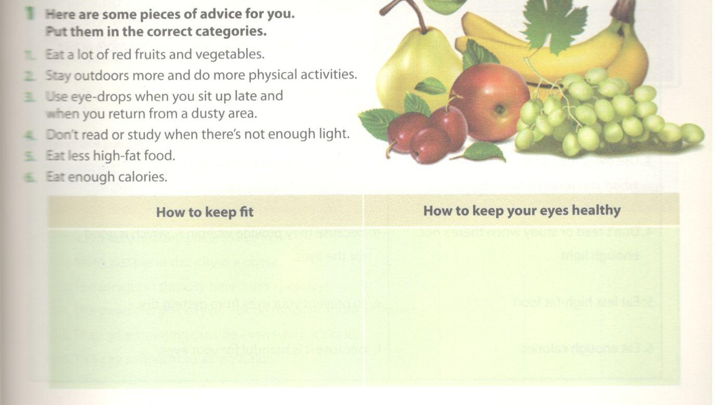
Key - Đáp án:
ow to keep fit | How to keep your eyes healthy
2. Stay outdoors more and do more physical activities. | 1. Eat a lot of red fruits and vegetables.
5. Eat less high-fat food. | 3. Use eye-drops when you sit up late
6. Eat enough calories. | and when you return from a dusty
 | area.
 | 4. Don't read or study when there's
' | not enough light.
2. Here are the reasons for the advice in 1. Match them.
Dưới đây là các lý do cho lời khuyên ở bài 1. Hãy nối chúng lại.
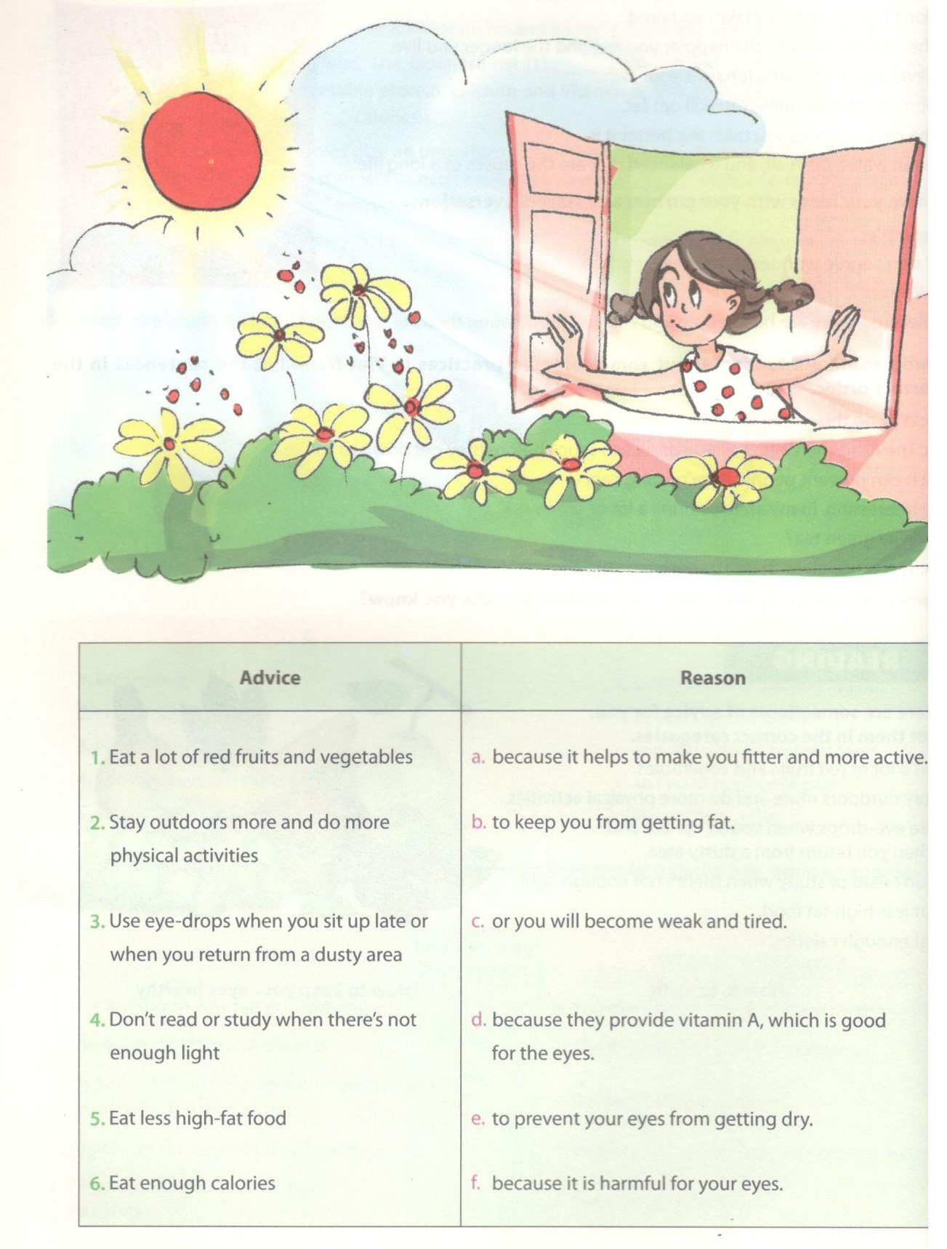
Key - Đáp án:
1.d; 2.a; 3.e; 4.f; 5.b; 6.c
3a. Read the passages and match them with the pictures.
Đọc đoạn văn và nối với bức trang tương ứng.
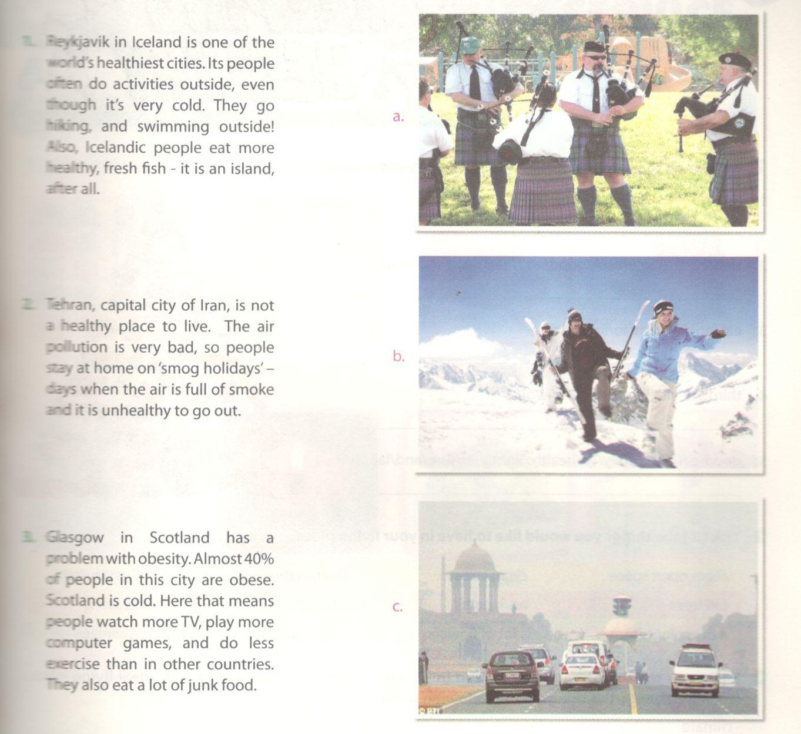
Key - Đáp án:
1.b; 2.c; 3.a
3b. Read the passages again and tick the place that each statement refers to.
Đọc lại đoạn văn và đánh dấu tick vào địa điểm mà các câu có liên quan.

Statements | Reykjavik | Tehran | Scotland
' it is a very healthy place to live in.
2 Many people in this city are obese.
3. The people in this city have'smog holidays'.
- The people in this city do not do much outdoor activities. 5. They go swimming outside even when it's cold.
5. This city suffers from air pollution.
Key - Đáp án:

Tehran | Scotland
1,5 | 3,6 | 2,4

E. Writing – trang 16 – Unit 2 – Sách bài tập( SBT) tiếng Anh 7 mới
1. Rearrange the words to form some tips for a healthy living.
Sắp xếp lại các từ để tạo thành câu mang nghĩa là lời khuyên cho cuộc sống khỏe mạnh.
1. apple/keeps/An/day/doctor/a/the/away/.
2. sleep/are/the/cures/A/good/and/best/laugh/a/long/.
3. eat/not/live/Eat/to/live/ ,/to/.
4. thirds/health/Hygiene/two/is/of/.
5. good/eat/cheerfullyATb/health:/lightly/ensure/and/laugh/.
Key - Đáp án:
1. An apple a day keeps the doctor away.
2. A good laugh and a long sleep are the best cures.
3. Eat to live, not live to eat.
4. Hygiene is two thirds of health.
5. To ensure good health: eat lightly and laugh cheerfully.
2. Tick (✓) the things you would like to have in your living place.
Đánh dấu (✓) với những điều bạn muốn có ở nơi bạn sinh sống.

more open space | clean streets | clean water | a KFC restaurant
tall trees | walk paths | A factory | four seasons
A dumping site | A lot of flowers | A sports centre | warm climate
3. Basing on the things you have chosen in 2,write a short passage about your ideal living. You may arrange the things in the following order:
Dựa vào những điều bạn đã chọn trong bài 2, viết một đoạn văn ngắn về nơi sống lý tưởng của bạn. Bạn có thể sắp xếp các điều đó theo yêu cầu dưới đây:
