Giải bài tập SBT Tiếng Anh lớp 8 Unit 3 AT HOME
1. Complete the following sentences with have to or must. (Trang 25 sách Bài tập Tiếng Anh 8)
a. have to/ must b. have to/ must
c. have to d. have to
e. have to/ must f. have to/ must
g. does – have to h. must
i. has to j. must
2. You are giving advice to a friend. Use ought to or ought not to. (Trang 25-26 sách Bài tập Tiếng Anh 8)
a. You ought to go to the dentist.
b. You ought to learn a few Chinese words before you go.
c. You ought not to ride a bicycle so fast because it is dangerous.
d. You ought to put on warm clothes.
e. You ought to stay at home this evening.
f. You ought not to watch TV too much because you are going to have final exams.
g. You ought to stop smoking.
h. You ought to improve your English before you go to the USA.
3. Complete the following sentences, using myself, yourself, himself, herself, itself, ourselves, themselves with the verbs in the box. (Trang 26-27 sách Bài tập Tiếng Anh 8)
a. repaired ... myself b. look after ourselves
c. enjoyed themselves d. clean ... youself
e. drew ... himself f. looked at herself
g. made ... herself
4. Write complete sentences with the verbs in the box. Use reflexive pronouns only where necessary. (Trang 27-28 sách Bài tập Tiếng Anh 8)
a. feel d. enjoyed ourselves
b. dried himself e. concentrate
c. met f. teach
g. wash
5. Match the question in (I) with the appropriate answer in (II) using Why – Because. (Trang 28-29 sách Bài tập Tiếng Anh 8)
a. D | b. G | c. C | d. F
e. H | f. A | g. B | h. E
6. Read the following situation and then make up questions and answer them. (Trang 29-30 sách Bài tập Tiếng Anh 8)
a.
A: Why didn't Mrs. Brown get any milk?
B: Because the shops were closed.
b.
A: Why did David go in his place?
B: Because the headmaster was ill.
c.
A: Why didn't they go to the beach?
B: Because it rained all day and night.
d.
A: Why did Mr. Brown miss the train to Leeds?
B: Because his car broke down on the way to the railway station.
e.
A: Why did Bob get lost?
B: Because he didn't have a city map.
7. Crossword. (Trang 30-31 sách Bài tập Tiếng Anh 8)
All the answers are prepositions (on, next to, in front of, between, in, under, behind). The passage will help you. (Trang 30-31 sách Bài tập Tiếng Anh 8)
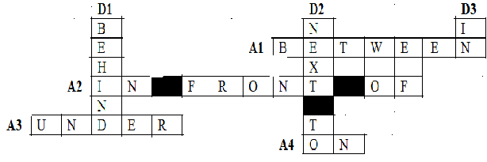
8. Complete the sentences using must, mustn't, have to, not have to (in the correct form.) (Trang 31 sách Bài tập Tiếng Anh 8)
a. mustn't b. have to c. must
d. had to e. don't have to f. mustn't
9. Fill in each gap with one word from the box. There are more words than you need to fill in all the gaps. (Trang 31-32 sách Bài tập Tiếng Anh 8)
a. vacuum cleaner b. washing machine
c. bathtub d. cupboard
e. microware oven f. water heater
g. hairdryer
10. Read the passage and answer the multiple – choice questions. (Trang 32-33 sách Bài tập Tiếng Anh 8)
a. C | b. C | c. B | d. A | e. A

