Giải bài tập SBT Tiếng Anh lớp 8 Unit 8 COUNTRY LIFE AND CITY LIFE
1. Write the full sentences (expressing future arrangements). Put the verbs in the present progressive tense. (Trang 69 sách Bài tập Tiếng Anh 8)
a. I am visiting my grandparents this Sunday.
b. Liz's family are coming to stay there this weekend.
c. Is Ba working late tonight, too?
d. We are not coming home this weekend.
e. He's going to see the dentist this afternoon.
f. They are going back to the USA for 2 months.
2. Complete the sentences, using the correct present progressive form of the verbs in the box to talk about future plans. (Trang 69-70 sách Bài tập Tiếng Anh 8)
a. is leaving b. are studying c. are moving
d. am finishing e. is flying f. am seeing
3. Look at Mrs. Lien's diary for next week. Complete what she says she is doing next week. Use the words in the box. (Trang 70 sách Bài tập Tiếng Anh 8)
am going
am working
am not doing
am meeting
am seeing
am going
are ... doing
are ... doing
4. Put the verbs in brackets into the present simple or present progressive. (Trang 71 sách Bài tập Tiếng Anh 8)
a. visits b. is ... going c. are ... going d. play
e. am having f. work g. is ironing h. becomes
5. Complete the sentences about the world today using comparative sentences with GET or BECOME. (Trang 71 sách Bài tập Tiếng Anh 8)
a. are becoming more important b. is getting/ becoming bigger
c. is getting/ becoming worse d. are becoming polluted
e. is becoming automated f. are becoming harder.
6. Read the situations and complete the sentences. Use the comparative forms (-er or more …) or the superlatives ( -est or the most) with given adjectives. (Trang 71-73 sách Bài tập Tiếng Anh 8)
a) The white shirt is cheaper than the yellow one.
- The yellow shirt is more expensive than the white one.
b) is the newest
- is the oldest
- older than ... the oldest
c) is the slowest
- is faster than going by bike
- is the fastest.
d) is more popular than the normal style
e) is more comfortable than Mr. Black's house
f) is larger than a department store
- is smaller than a mall
g) is smaller than the Mall of Canada
- is bigger than the Mall of America
h) more convenient than shopping in a shop
i) is the coldest
- is warmer than Sunday
- is the warmest
j) is the youngest
- is younger than Ha Noi and older than Ho Chi Minh City
- is the oldest city
k) is the least crowded
- is les crowded than Ho Chi Minh City
- is the most crowded
7. Future intention (I) or showing changes (C)? Check the correct column. (Trang 74 sách Bài tập Tiếng Anh 8)
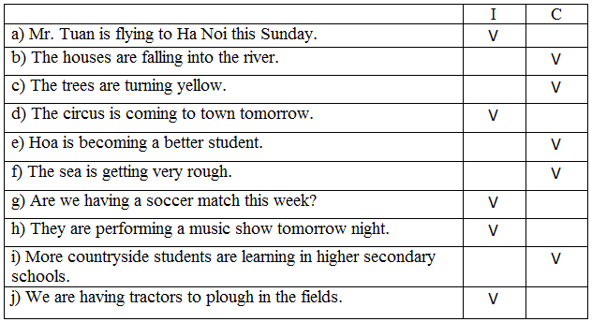
8. What are typical of city and country life? Put the followings in groups. (Trang 74 sách Bài tập Tiếng Anh 8)
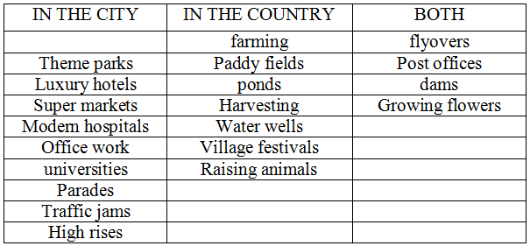
9. Read the passage and fill in each gap with a suitable word or phrase. Circle A, B, C or D. (Trang 75-76 sách Bài tập Tiếng Anh 8)
1. B | 2. A | 3. C | 4. D | 5. B
6. A | 7. C | 8. B | 9. A | 10. A
11. D | 12. C | 13. B | 14. A | 15. C
10. Read the passage and answer the multiple-choice questions. (Trang 76-77 sách Bài tập Tiếng Anh 8)
a. C | b. A | c. D | d. C | e. D | f. C

