Giải SBT Tiếng Anh 9 Unit 9: Natural disasters
1. (trang 86 sbt Tiếng Anh 9): Which postcard do you like? Which postcard do you dislike? Use that or which in your answers.
Suggested answers:
a. I like the postcard which shows a beautiful sunrise.
b. I dislike the postcard which shows terrifying lightnings.
c. I dislike the postcard which shows a violent eruption.
d. I like the postcard which shows a cloudy sky.
e. I like the postcard which shows a glorious sunset.
f. I like the postcard which shows a sunny day in Ha Long.
2. (trang 87 sbt Tiếng Anh 9): What do you know about Viet Nam? Complete each sentence below with a non-defining clause that gives additional information about a province or a City in Viet Nam.
Suggested answers:
a. Last year Mrs. Nelson taught English in Ho Chi Minh City, which is the largest City in Viet Nam.
b. We last visited Da Nang, which is one of the major port cities in Viet Nam
c. Tourism is thriving in Quang Ninh, which is home to Ha Long Bay, a World Heritage Site.
d. Khanh Hoa, whose Capital is Nha Trang, was 300 years old in 2003 Khanh Hoa, which is located in the South Central Coast, was 300 years old in 2003.
e. Mr. and Mrs. Anderson can neyer forget their trip to Hue, which is famous for its beauty spots and royal tombs.
f. In 2002, many foreign investors started their business in Binh Duong, which is considered to be good cropland and is also home to a signiíĩcant manuiacturing industry.
g. The tourists wanted to go to Bac Ninh, which is a City in the Northern part of Viet Nam, before they left Viet Nam.
h. It is 90 kilometers from Ha Noi to Nam Dinh, which is a City in the Red River Delta of northem Viet Nam.
3. (trang 88 sbt Tiếng Anh 9): Fill in the gap in each sentence with one suitable word.
a. Have you ever been struck by lightning?
b. The Amazon river basin has the world’s largest tropical rainforest.
c. Scientists are very interested in tidal power. They are thinking of how to use the rise and fall of the tide to produce electricity.
d. The girl fell into the river but a passer-by saved hẹr from drowning.
e. Only the female mosquito can suck blood and transmit malaria.
f. Some species of turtle can stay underwater for 24 hours.
4. (trang 88 sbt Tiếng Anh 9): What are the words? Find the words which describe natural disasters and weather conditions in the puzzle. You can find 12 more words.
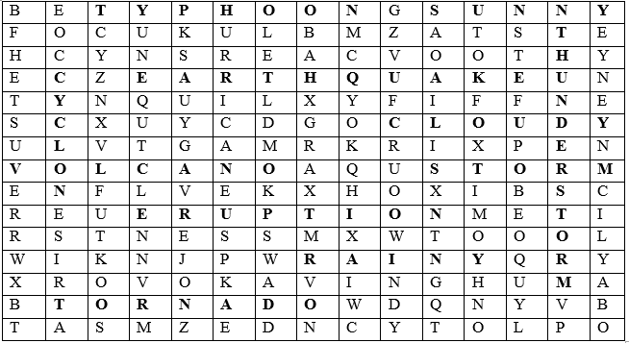
5. (trang 89 sbt Tiếng Anh 9): Look at the weather forecast and write sentences.
a. Ha Noi, which is the capital city of Viet Nam, will be partially cloudy.
b. Tokyo, which is the capital city of Japan, will be sunny.
c. Bangkok, which is the capital city of the United States, will be cloudy.
d. Canberra, which is the capital city of Australian, will experience thunderstorms.
e. Moscow, which is the capital city of Russia, will be rainy.
6. (trang 90 sbt Tiếng Anh 9): Study the state map of the United States and read the descriptions. Match the name of the state with the right description given.
1. d | 5. e
2. f | 6. h
3. c | 7. g
4. a | 8. b
Now write the description of the above states, following the example.
1. North Carolina is the state which is bordered by Virginia to the north.
2. Rhode Island is the state which is bordered by Massachusetts to the north.
3. Kansas is the state which is north of Texas and is bordered by Maryland to the east.
4. Indiana is the state which is bordered by Ohio to the east, Illinois to the west, Michigan to the north and Kentucky to the south.
5. California is the state which is bordered by the Pacific to the west and Arizona to the southeast.
6. Tennessee is the state which is bordered by nine other states of the United States.
7. Montana is the state which is northeast of Nevada and is bordered by Canada to the north.
8. Florida is the state which is bordered by Georgia to the north and Alabama to the northwest.
7. (trang 92 sbt Tiếng Anh 9): Fill in each gap with ONE suitable word.
1. in | 6. until
2. agricultural | 7. struck
3. of | 8. caused
4. produced | 9. broke
5. which | 10. More
8. (trang 92 sbt Tiếng Anh 9): Use a word from the box to start each paragraph below.
1. Tornadoes | 4. Earthquakes
2. Volcanoes | 5. Drought
3. Tsunami | 6. Hurricanes
9. (trang 93 sbt Tiếng Anh 9): What to do during an earthquake? Read the following and decide what one should do during an earthquake. Check YES or NO.
1. YES | 6. YES
2. YES | 7. NO
3. NO | 8. YES
4. YES | 9. NO
5. YES | 10. NO
10. (trang 94 sbt Tiếng Anh 9): Read the passage and answer the multiple-choice questions. Circle A, B, C or D.
1. D | 4. B
2. B | 5. C
3. B | 6. A

