Giải bài tập Lesson Three Unit starter - Family & Friends Special Edittion Grade 2
1. Listen, point, and repeat.
Script:
one: 1
two: 2
three: 3
four : 4
five: 5
six: 6
seven: 7
eight: 8
nine: 9
ten: 10
2. Listen and check (√)
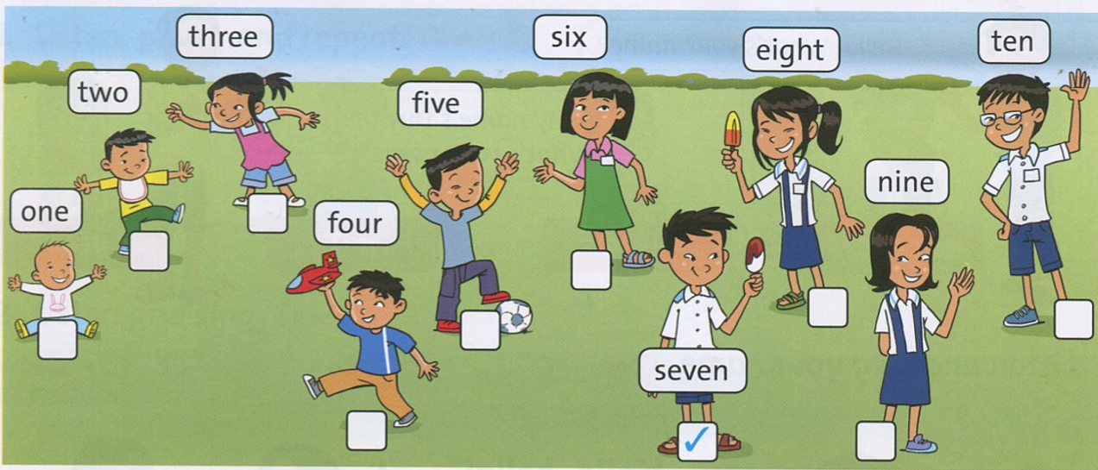
3. Look at the picture again. Point, ask, and answer.
How old are you? => I'm seven.
Hướng dẫn:
one: How old are you? => I'm one.
two: How old are you? => I'm two.
three: How old are you? => I'm three.
four: How old are you? => I'm four.
five: How old are you? => I'm five.
six: How old are you? => I'm six.
seven: How old are you? => I'm seven.
eight: How old are you? => I'm eight.
nine: How old are you? => I'm nine.
ten: How old are you? => I'm ten.
4. Listen and point.
5. Listen and chant.
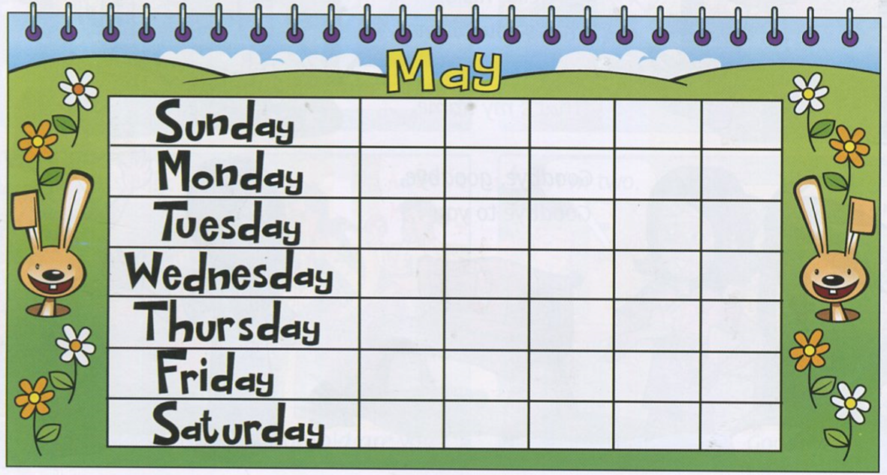
Script:
Sunday: chủ nhật
Monday: thứ Hai
Tuesday: thứ Ba
Wednesday: thứ Tư
Thursday: thứ Năm
Friday: thứ Sáu
Saturday: thứ Bảy

